### sh BookDiskplay1

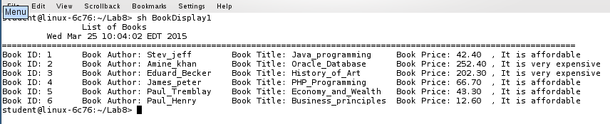

### sh BookDiskplay2

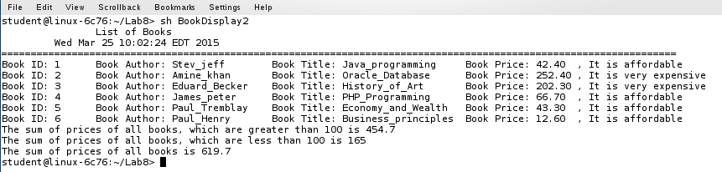

### sh BookDisplay3

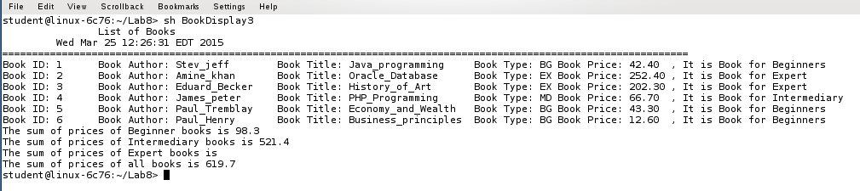

### sh ProductDisplay4

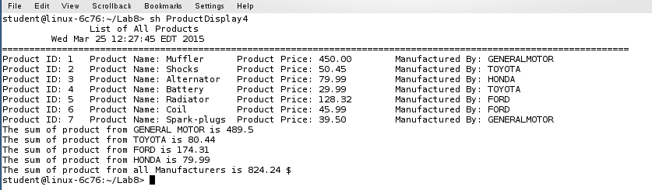

### sh EmployeeDisplay1

